Name : Sumama Rahim Registration # F24BSCS039
LAB ACTIVITY 6
Generate key as per length of the text, key must be generated randomly(one time pad)
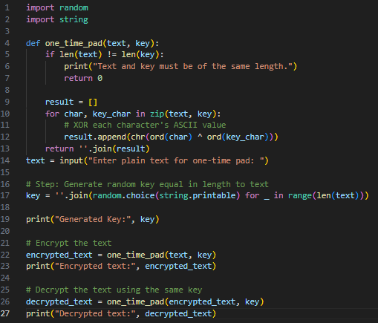

OUTPUT
